CP9120 Network Configuration Tool Operation Instructions

1 Set the software language

Change the non-Unicode program language in the "Control Panel->Clock and Region->Region->Administrative" window to Chinese/English, then restart and reopen the configuration tool.

The steps to switch from English to Chinese are as follows：

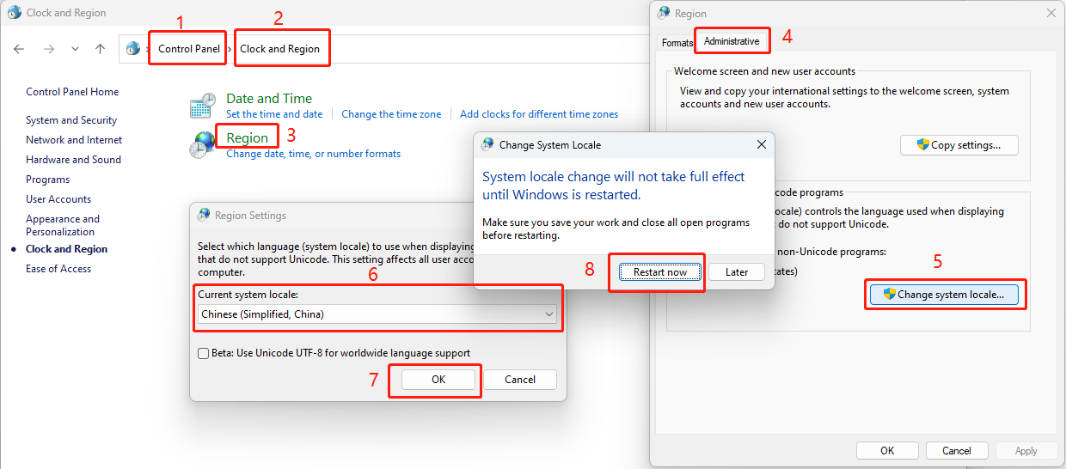

The steps to switch from Chinese to English are as follows：

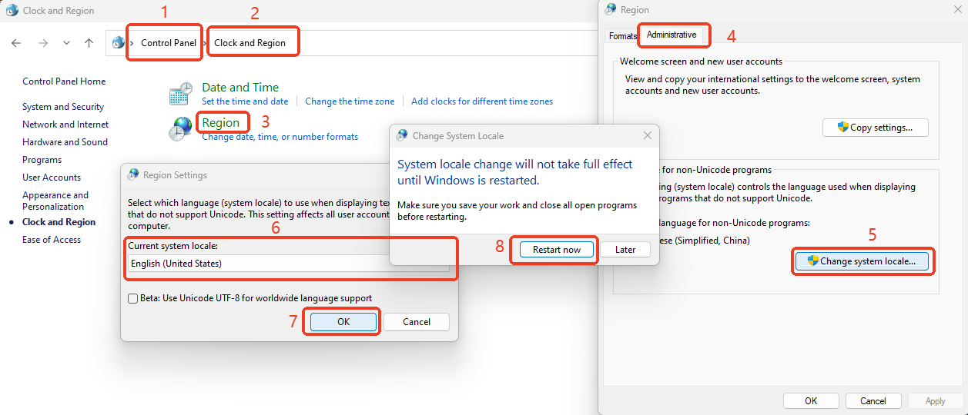

2 Device query and network port function configuration

2.1 Device query

1）Open the configuration tool and click "Search ". The tool uses UDP broadcast to search for online devices. After the UDP broadcast ends, the online devices that respond will be displayed in the "Module List".

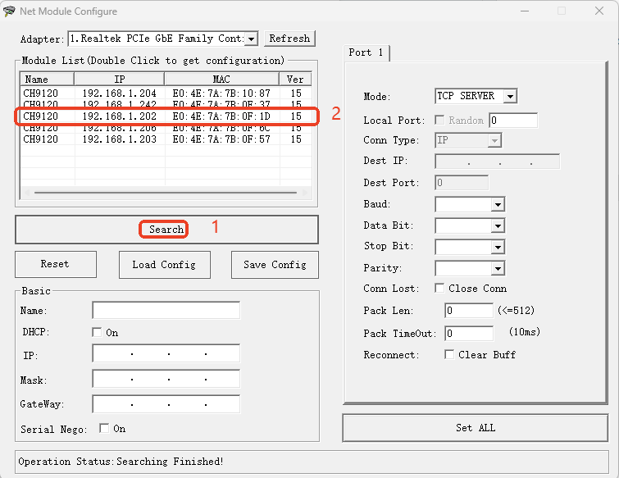

2）Double-click the device you want to view, and the configuration information of the device will be displayed in the "Basic " and "Port 1" blocks.

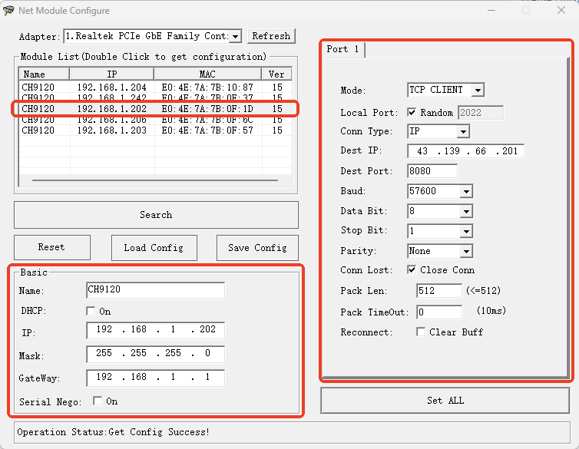

2.2 Device network port function configuration

Before configuring parameters, ensure that the parameters displayed in the two blocks "Basic " and "Port 1" are the parameters of the device to be configured. If not, follow the two steps in 2.1 and select the device to be configured.

2.2.1 Uneditable items

The serial port related parameters in the red box in the figure below are non-modifiable items and should remain at the factory configuration as shown in the figure below.

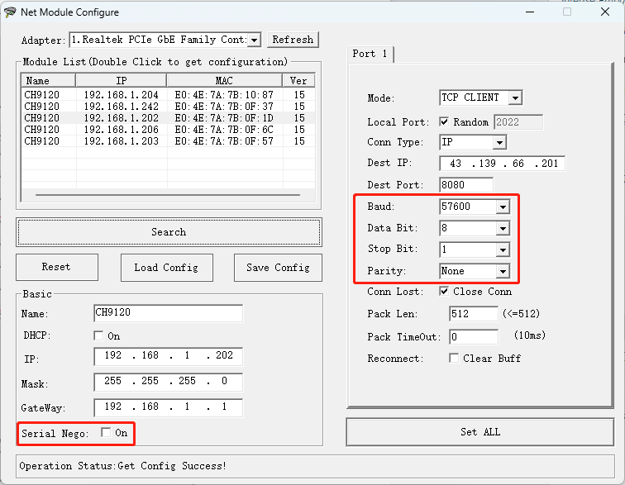

2.2.2 Device IP address related parameter configuration

1）In the Basic Settings section, modify the device's Device IP, Subnet Mask, and Gateway.；

2）Click "Set All"；

3）Wait until the "Operation Status" shows "Rebooting Finished", and the device has completed the parameter modification.

As shown in the following figure:

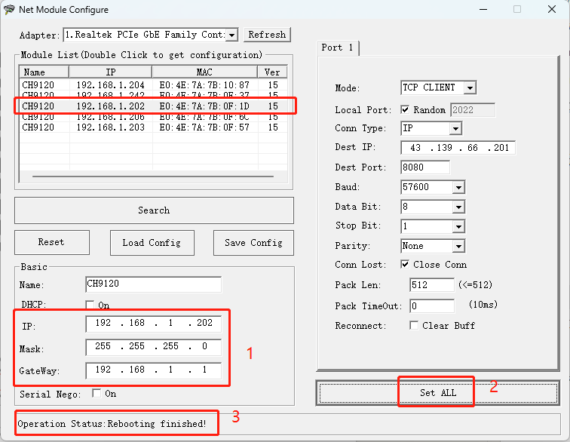

2.2.3 TCP SERVER Mode Configuration

1）In the "Port 1" block, change "Mode" to "TCP SERVER"；

2）In the "Port 1" block, change the "Local Port" to the value you want to configure；

3）Click "Set all"；

4）Wait until the "Operation Status" shows "Rebooting Finished", and the device has completed the parameter modification.

As shown in the figure below：

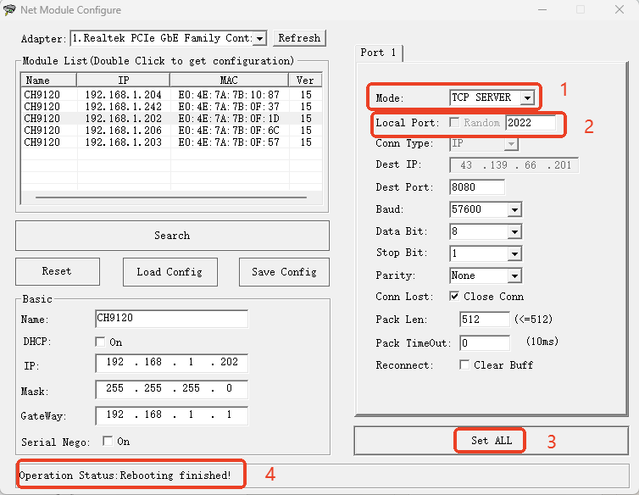

2.2.4 TCP CLIENT Mode Configuration

1）In the "Port 1" block change the "Mode" to "TCP CLIENT"；

2）In the "Port 1" block, change the "Local Port" to the value you want to configure, or check "Random"；

3）In the "Port 1" block, change the "Dest IP" to the remote server IP to be configured；

4）In the "Port 1" block, change the "Dest Port " to the remote server port number to be configured.；

5）Click "Set all"；

6）Wait until the "Operation Status" shows "Rebooting Finished", and the device has completed the parameter modification.

As shown in the figure below：

